**Home Network Topology**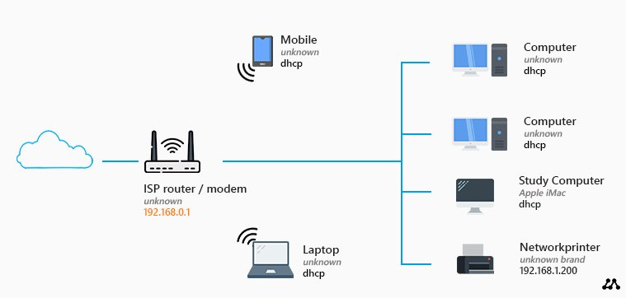

* **ISP**: The Internet Service Provider provides internet connectivity to the home.
* **Modem**: The modem connects to the ISP and converts the internet signal into a form that can be used by the router.
* **Router**: The router connects to the modem and distributes the internet connection to various devices within the home network.
* **Devices**: Devices such as laptops, smartphones, smart TVs, and IoT devices connect to the router either via wired (Ethernet) or wireless (Wi-Fi) connections.

**Accessing the RPS Lab environment:**

1. **VPN Connection**: I use a Virtual Private Network (VPN) to securely connect to the RPS (Remote Problem Solving) Lab environment. The VPN creates a secure and encrypted connection between my device and the RPS Lab network, allowing me to access resources in the lab securely.
2. **Remote Desktop Protocol (RDP)**: Once connected to the RPS Lab network via VPN, I use Remote Desktop Protocol (RDP) or a similar remote access protocol to remotely connect to specific lab machines or servers. This enables me to interact with the lab environment as if I were physically present in the lab, allowing me to perform tasks, run experiments, or troubleshoot issues remotely.
3. **Authentication**: Access to the RPS Lab environment may require authentication using credentials provided by the lab administrator. This ensures that only authorized users can access the lab resources and maintain security.
4. **Firewall and Security Measures**: The RPS Lab environment may be protected by firewalls and other security measures to prevent unauthorized access and ensure the integrity and confidentiality of lab resources and data.